Demo 2 : Assigning Jobs to Specific Slave (master slave second part)

This section will guide you to:

* Connect and assign jobs to the selected slave machines configured for the build

This guide has four subsections, namely:

1. Logging in to Jenkins
2. Creating slave nodes
3. Building job with slave machine
4. Pushing code to GitHub repositories

**Step 1:** Logging in to Jenkins

* Open your browser and navigate to **localhost:8081**
* Provide your username and password and click on **Login**

**Step 2:** Creating slave nodes

* Navigate to **Manage Jenkins**
* Click on **Configure Global Security**

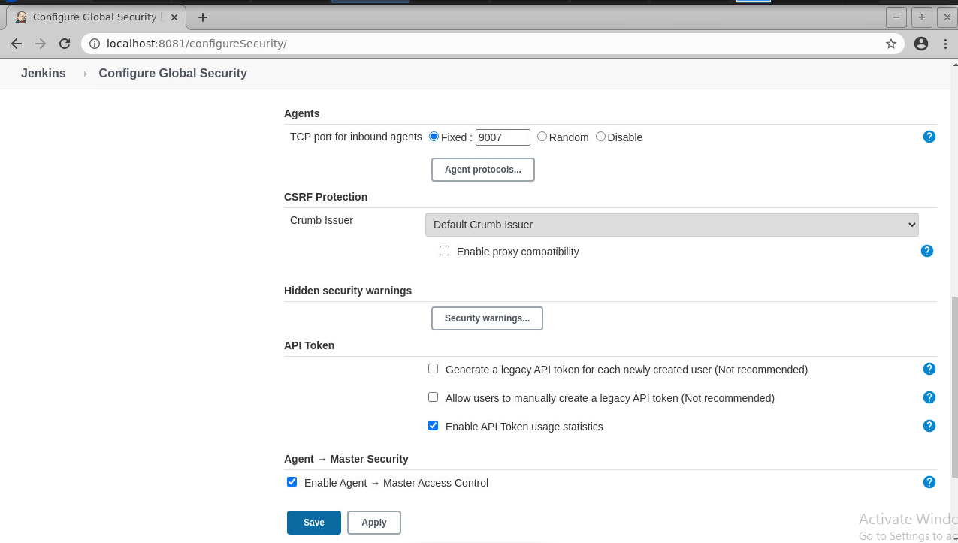

* Scroll down to Agents and enable inbound traffic at port 9007
* Click on **Apply** and then click on **Save**
* Navigate to **Manage Jenkins**
* Click on **Manage Node and Clouds**
* Click on **New Node**
* Enter a **node name** and check the **permanent agent** button
* Click on **OK**

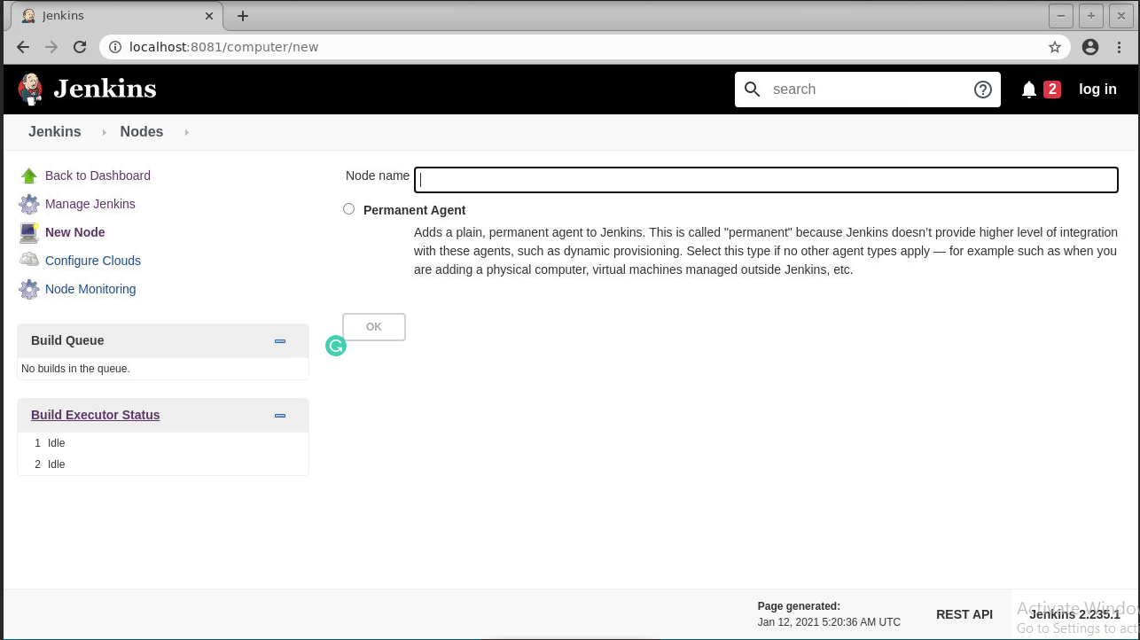

* Provide name, number of executors, root directory path, label, usage, and launch method as shown below:

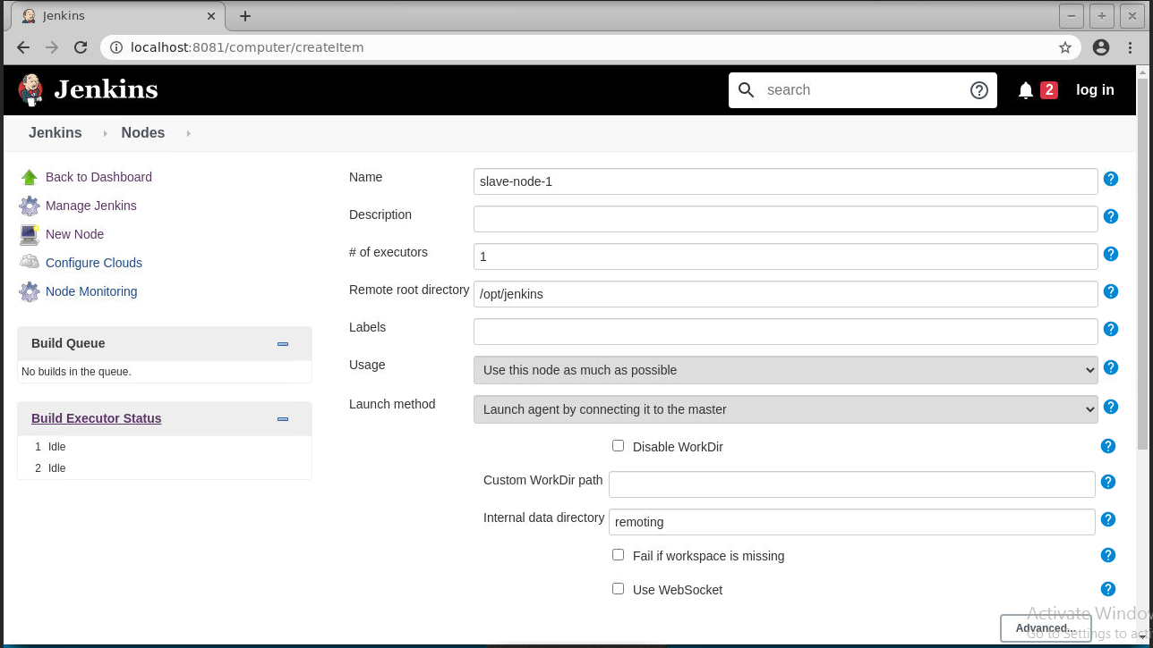

* Then click on **Save**
* Once the configuration is complete, you can see the slave machine on the dashboard

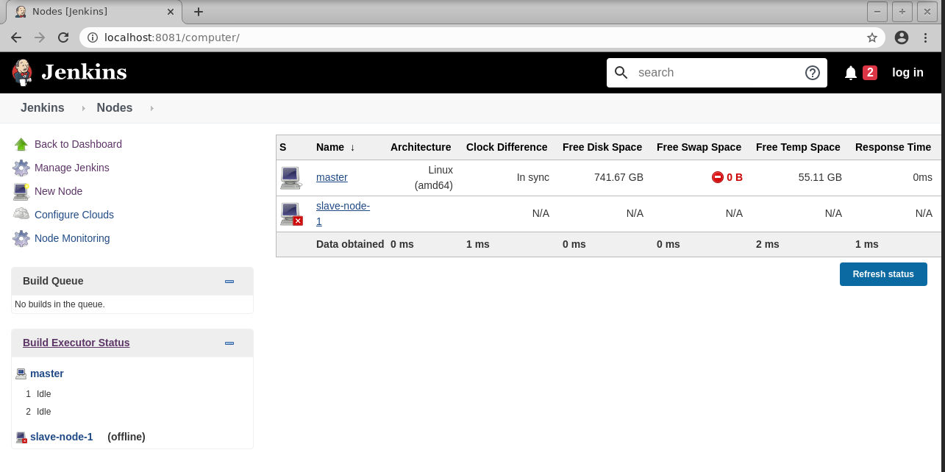

* Click on the slave-node-1. You will see the following screen:

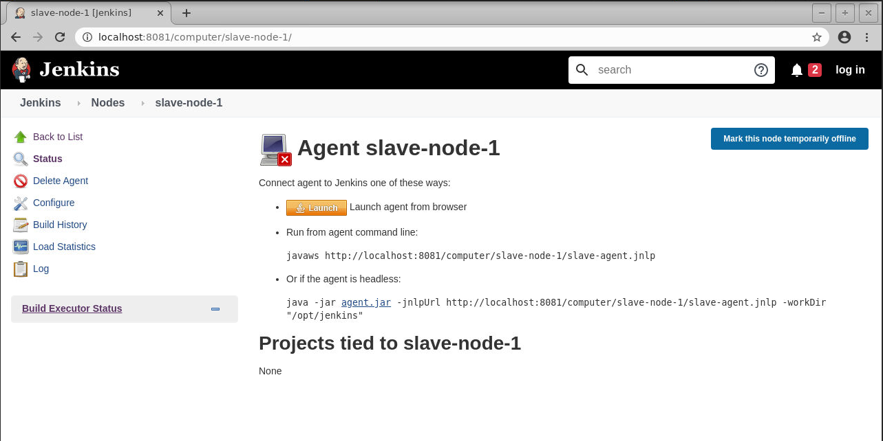

* Create a directory at the path specified as the Remote root directory

**sudo mkdir /*opt/jenkins***

***cd opt/jenkins***

* Download the **jar** file in the ***/opt/jenkins*** by running the following command:

**sudo wget http://localhost:8081/jnlpJars/agent.jar**

* Now copy the command shown in the agent slave-node-1

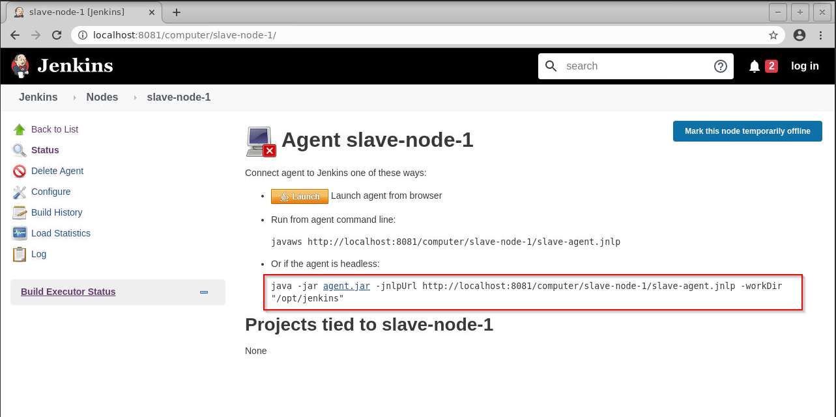

* Run the command to start the slave node

**sudo java -jar agent.jar -jnlpUrl http://localhost:8081/computer/slave-node-1/slave-agent.jnlp -workDir "/opt/jenkins"**

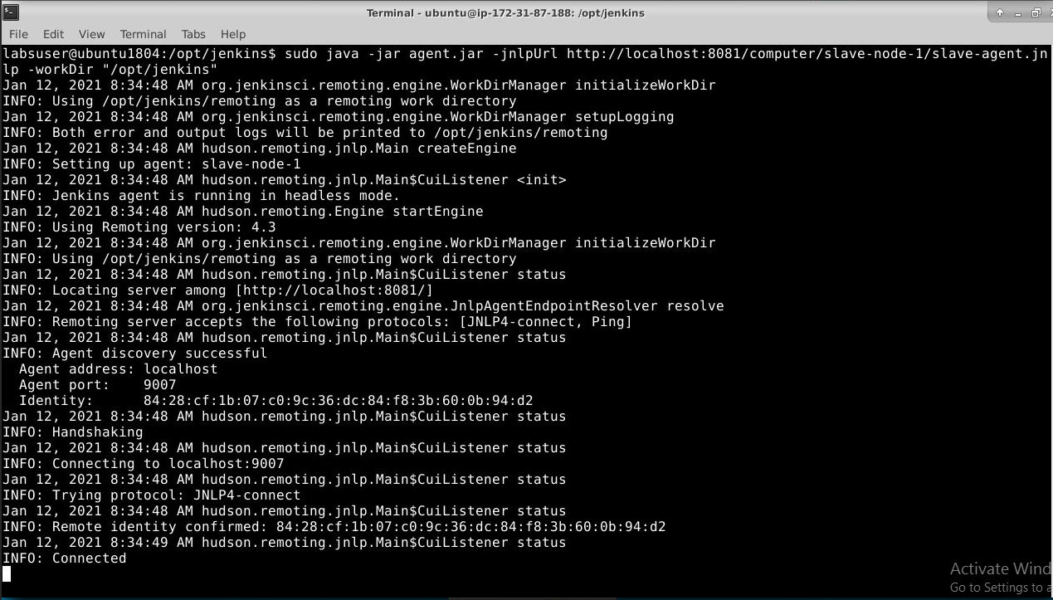

* The slave node will show as connected to the master UI

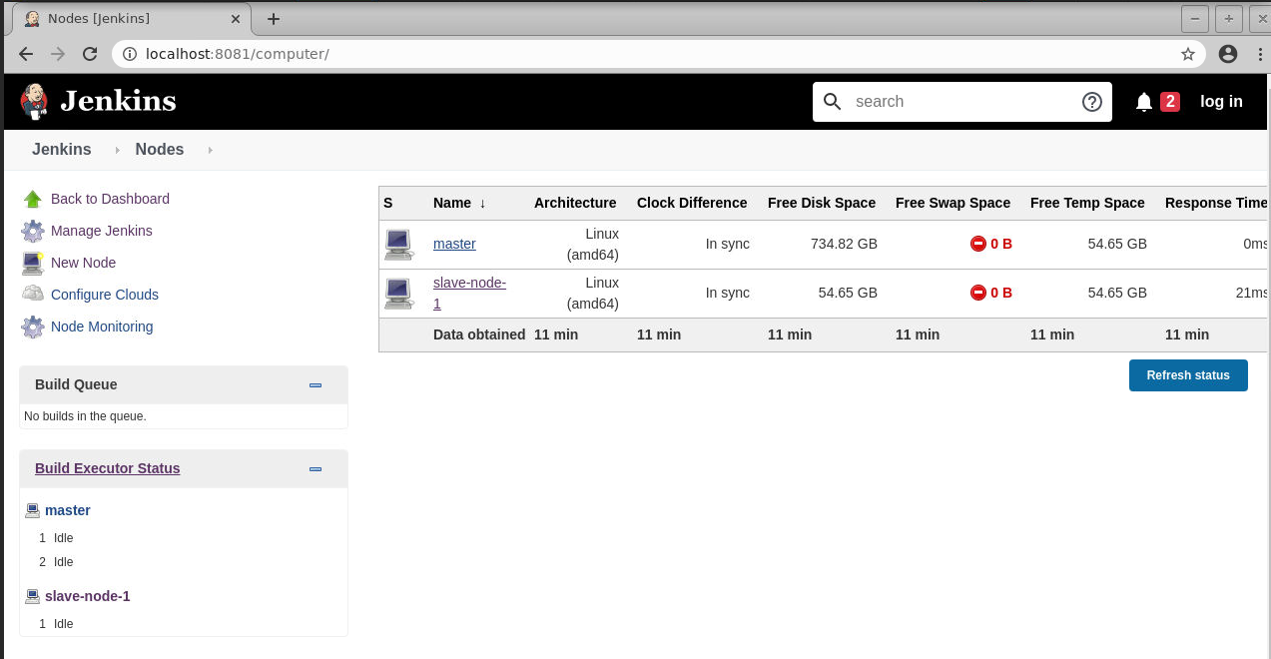

**Step 3:** Build job with slave machine

* Create a new **freestyle** job.
* In the configuration page, check the **Restrict where this project can be run** option as shown in the screenshot below and select **slave-node-1**

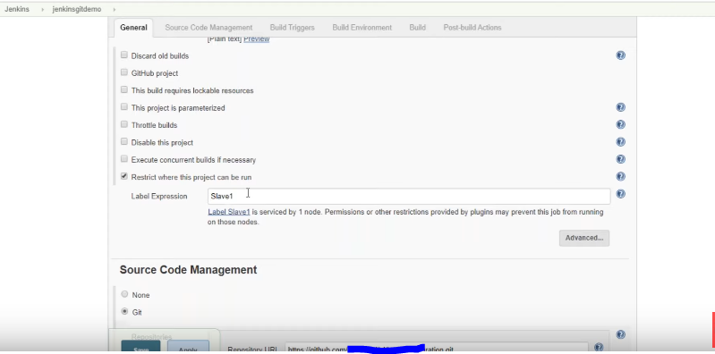

* Provide the URL to the repository of the source code in the **Source Code Management** section

**Please note**: you can use the sample-git repository that we had created in the earlier demos

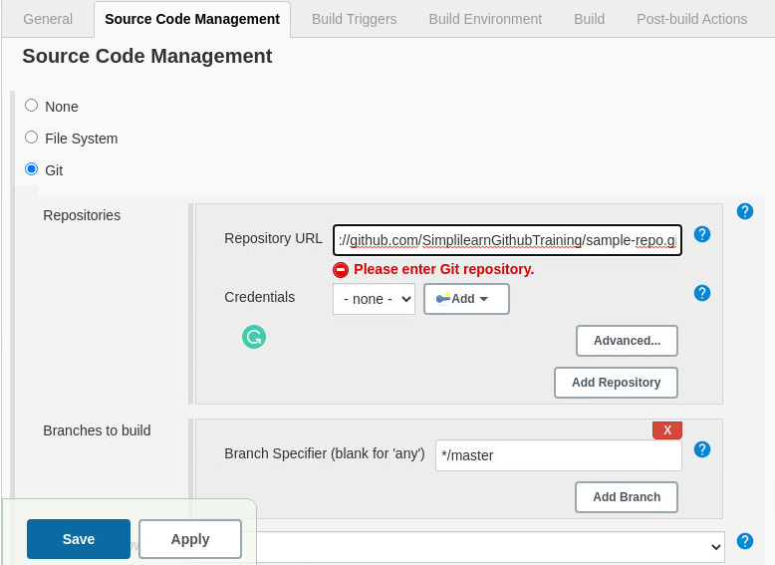

* Click on **Apply** and then click on **Save**
* Build the job and check the output in the console